Variable for String:
- A Variable is something that holds a value that may change.
- In simplest term a variable is just a box that you can put Stuff in.
- You can use variable to store all kind of stuff, but for now, we are just going to look at storing strings in variables.
Variable for Numbers:
- Variable of numbers are a storage placeholder for numbers (integers)
- We may also store float in variables.
Example:
Lucky_number = 9
print(Lucky_number)
output: 9
num_1=56.98
print(num_1)
outputs:56.98
name=”president Initiative for AI and Computing”
print(name)
- Creates a variable called name.
- Assigns a string value “President Initiative for AI and Computing” in this Variable,
- Prints the string value stored inside this variable.

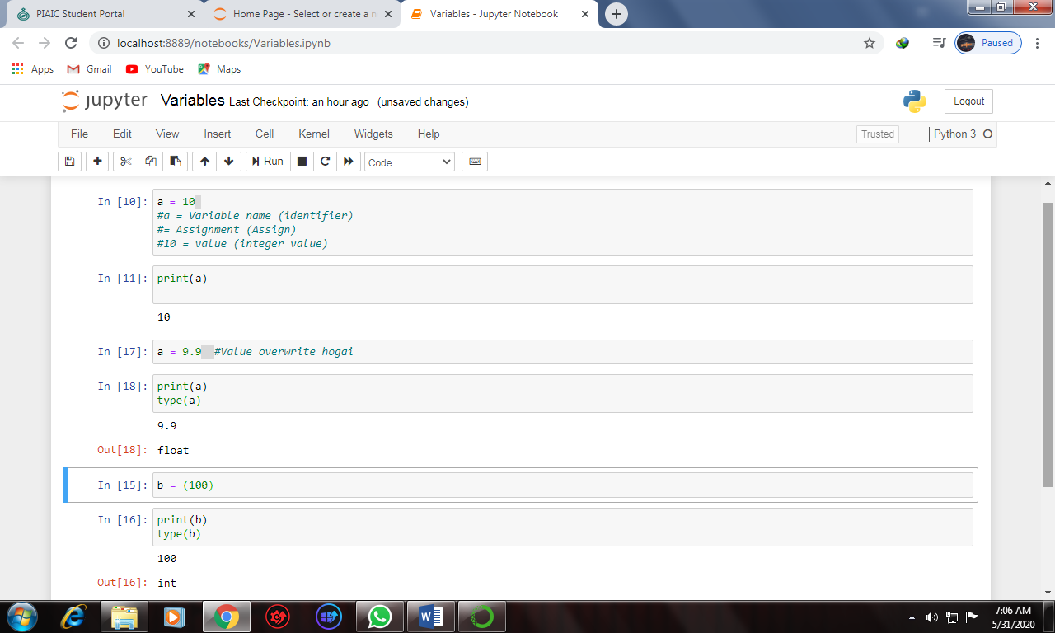
Type: #type Function is used for identifying the type data.

